2013年考研英语一考前作文押题
跨考教育英语教研室——张慧萍

Part A 应用文：

话题一：投诉信
预测题目：
Direction: You have bought a mobile phone from an ecommerce online store recently, but you found something wrong with it. Write a letter to Mr. Smith, the director of the consumer associations to
- make a complaint, and
- provide reasons for your complaint.
You should write about 100 words on ANSWER SHEET 2.
Do not sign your own name at the end of the letter. Use Li Ming instead.
Do not write the address. (10 points)
核心词汇：
disappointment (about), solve ( the problem), remedial measures, enhance (service), prevent, recurrence

话题二：邀请信
预测题目：
Direction: Your department has decided to hold an academic conference on environment protection next month. Write a letter to invite Professor Smith of Harvard University, an expert of this field, to deliver a speech. And ask him give you a confirmation.
You should write about 100 words on ANSWER SHEET 2.
Do not sign your own name at the end of the letter. Use The Students’ Union instead.
Do not write the address. (10 points)
核心词汇：
pleasure/honor, participate in, attend, schedule, arrangement

Part B 短文写作

话题一：社会道德/商业
预测题目
Directions: Write an essay of 160-200 words based on the following drawing. In your essay, you should
1) describe the drawing briefly,
2) interpret its social meaning
3) and give your comments.
You should write about 200 words neatly on ANSWER SHEET 2. (20 points)
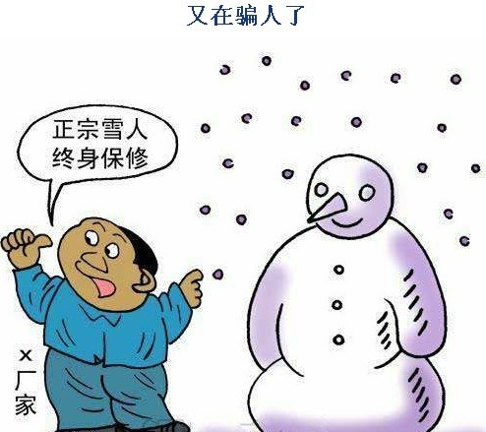
核心词汇
phenomenon（现象），issue（争议，焦点），enlightening（富有启发的），cause alarm and attention（引起了警惕和重视），corrupt people’s mind （腐化心灵），immoral behaviors（不道德的行为），at the cost of （以…为代价），human relations（人际关系），set good example for（为…树立榜样），dedicate（做贡献）, take action （采取行动），ensure implementing activities（确保执行）， impose punishment on them（施加处罚），aggravate the seriousness of…（使之恶化），commit crime（犯罪），vulnerable（易诱惑的，易受影响的），criteria of evaluation（衡量标准），be supposed to（应该）

话题二：中国好声音/骑马舞感染力文化
预测题目
Directions: Write an essay of 160-200 words based on the following drawing. In your essay, you should
1) describe the drawing briefly,
2) interpret its social meaning
3) and give your comments.
You should write about 200 words neatly on ANSWER SHEET 2. (20 points)
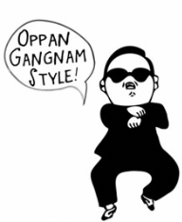今天你跳骑马舞了吗？

核心词汇
contagious culture (感染力文化) culture and civilization（文化和文明）， great and profound （博大精深的），diversity（多样性），integration and interaction（融合交汇），crash（碰撞）， original （原创原始的），minority （少数民族），revealing（有启发的），charming（极具魅力的），splendid（壮丽辉煌的），erotic（色情的）， talk show（谈话节目），horseback riding dance(骑马舞)

话题三：正能量（幸福）
Directions: Write an essay of 160-200 words based on the following drawing. In your essay, you should
1) describe the drawing briefly,
2) interpret its social meaning
3) and give your comments.
You should write about 200 words neatly on ANSWER SHEET 2. (20 points)
预测题目
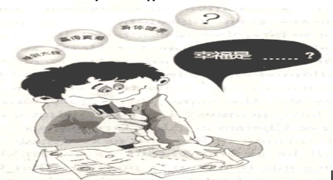

核心词汇
succeed, achieve success, spare no efforts/pains to do （不遗余力去做某事）, make great effort, be persistent with sth./ do with full persistence（坚持不懈地做某事）, fear to lose（害怕失败）， try every means to stay on top （尽一切努力取得成功），motive（动机），ambition（抱负），prominent (杰出的)，rank the top（名列前茅），versatile（多才多艺的），individual self-realization（自我实现）， stand up to/ withstand challenges and difficulties（经得住挑战与困难）

